Task: Series Circuit

Worksheet #1

Meets NATEF Task: (A6-A-5) Diagnose electrical/electronic integrity for series, parallel, and series-parallel circuits using principles of electricity. (Ohm’s Law).

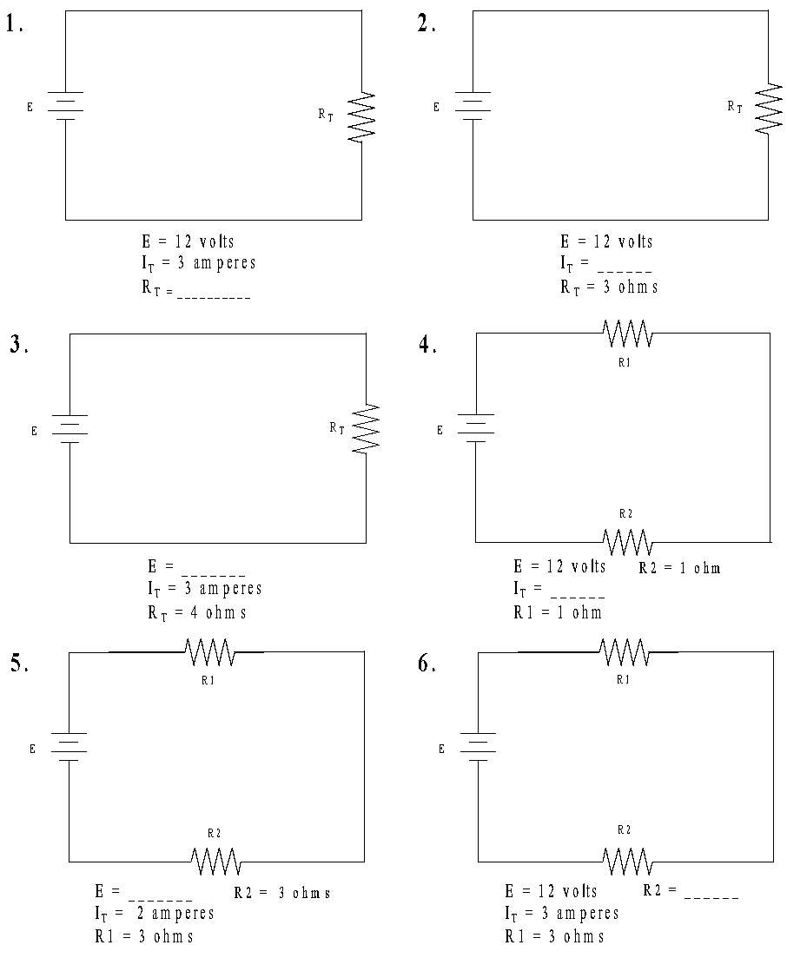

Series Circuit Worksheet #2

Meets NATEF Task: (A6-A-5) Diagnose electrical/electronic integrity for series, parallel, and series-parallel circuits using principles of electricity. (Ohm’s Law).
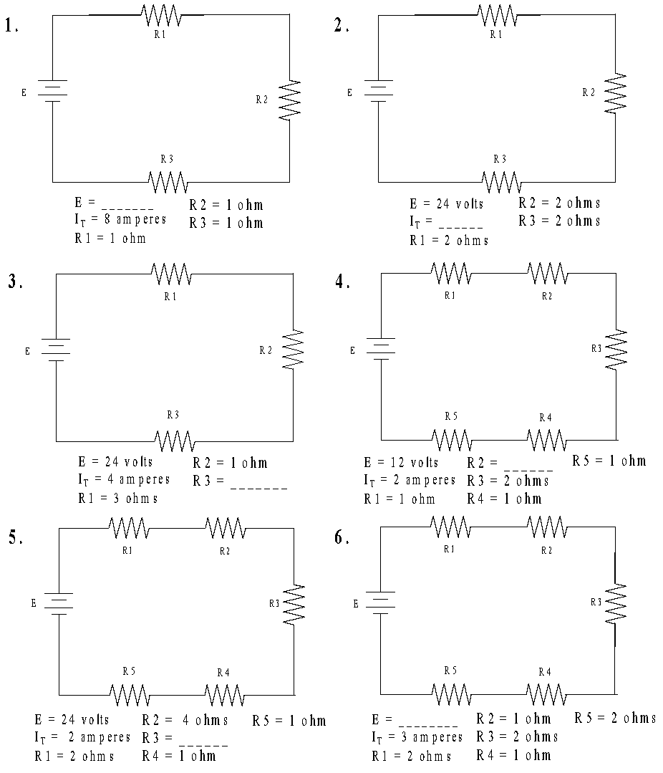

Series Circuit Worksheet #3

Meets NATEF Task: (A6-A-5) Diagnose Electrical/Electronic Integrity for Series, Parallel, and Series-Parallel Circuits Using Principles of Electricity (Ohm’s Law).
